**Joseph Patrick Lab: Structured Query Language (SQL) Queries Data Definition Language (DDL) Create Table**

**EXAMPLE – How your output should look for each table**

Campuses:

CREATE TABLE Campuses

(CampusID int,

CampusName varchar(20),

CONSTRAINT pk_campuses PRIMARY KEY (CampusID))

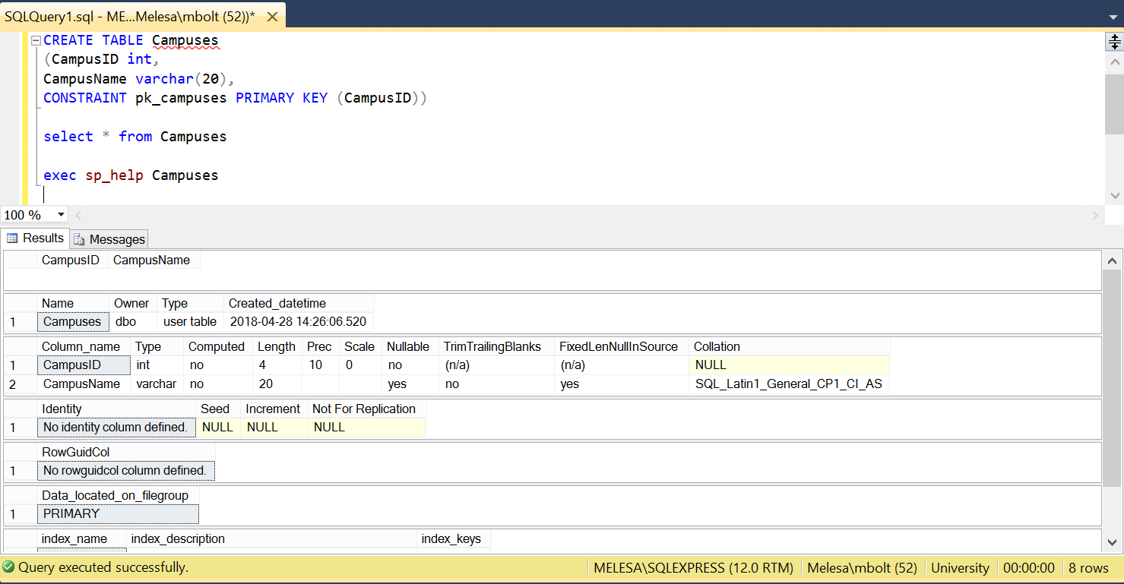

CREATE TABLE Campuses

(CampusID int,

CampusName varchar(20),

CONSTRAINT pk_campuses Primary Key (CampusID))

